**Project #1 (First Part)**

1. **Introduction**
2. **Explanation**
3. **Diagram**
4. ER Diagram

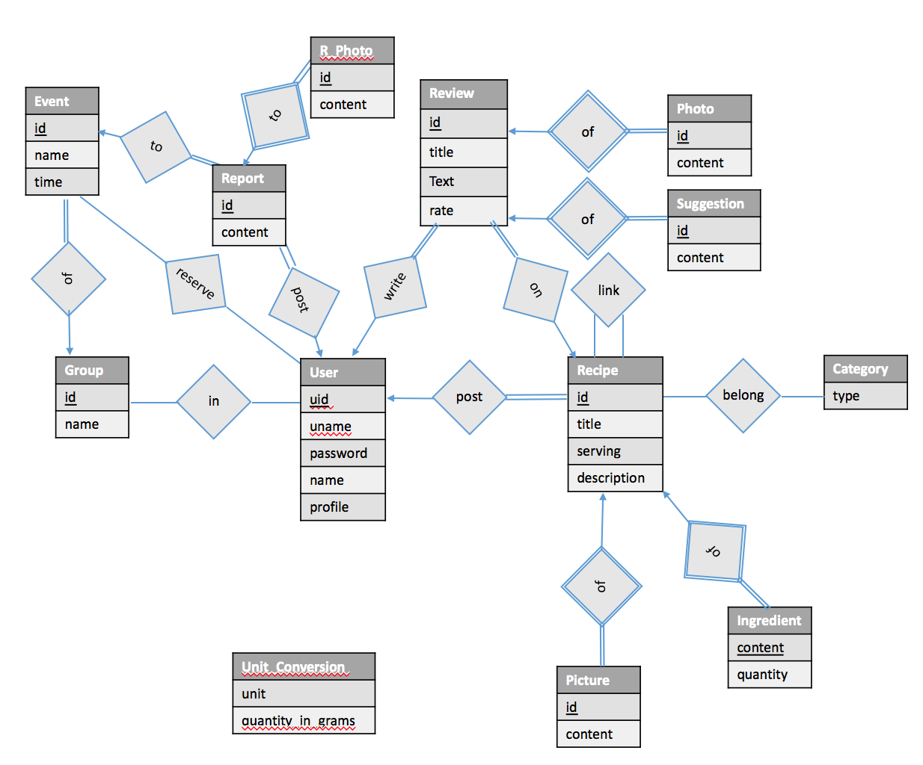

1. Relational Schema

User(uid, uname, upassword, name, uprofile)

Recipe(rid, uid, rtitle, rserving, rdescription)

Recipe_Picture(pid, rid, content)

Recipe_Tag(rid, tid)  
 Ingredient(rid, iname, iquantity)

Link_Recipe(rid, rid_link)

Review(r_id, rid, uid, rrate, rtext, rtitle)

Review_Photo(p_id, r_id, photo)

Review_Suggestion(sid, r_id, content)

Event(eid, gid, etime, elocation, edescription)

GGroup(gid, gname, gnumber, gdescription)

Join_Group(uid, gid)

Report(id, uid, eid, content)

Report_Photo(id, rpid, photo)

Rate(rank)

Unit_Conversion(unit_name, quantity_in_gram)

**Foreign Key References**

Recipe(uid) User(uid)

Recipe_Picture(rid) Recipe(rid)

Recipe_Tag(rid) Recipe(rid)

Ingredient(rid) Recipe(rid)

Link_Recipe(rid, rid_link) Recipe(rid)

Review(rid, uid) Recipe(rid) User(uid)

Review_Photo(r_id) Review(r_id)

Review_Suggestion(r_id) Review(r_id)

Event(gid) GGroup(gid)

Join_Group(uid,gid) GGroup(gid), User(uid)

Report(uid, eid) Event(eid), User(uid)

Report_Photo(rpid) Report(id)

1. **Test Data**
2. Create Tables and Constraints

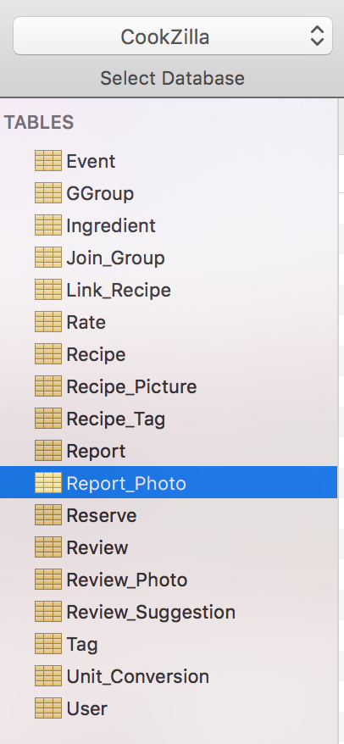

**Event**

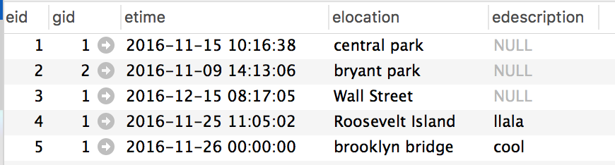

**GGroup Ingredient**

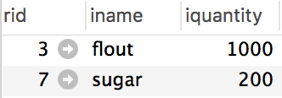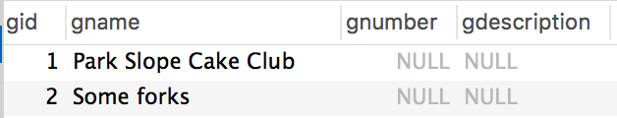

**Join_Group Link_Recipe Rate Recipe_Tag**

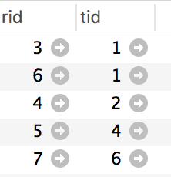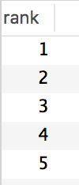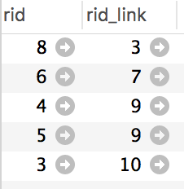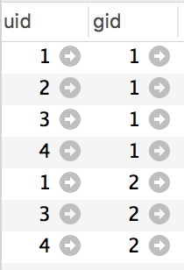

**Recipe**

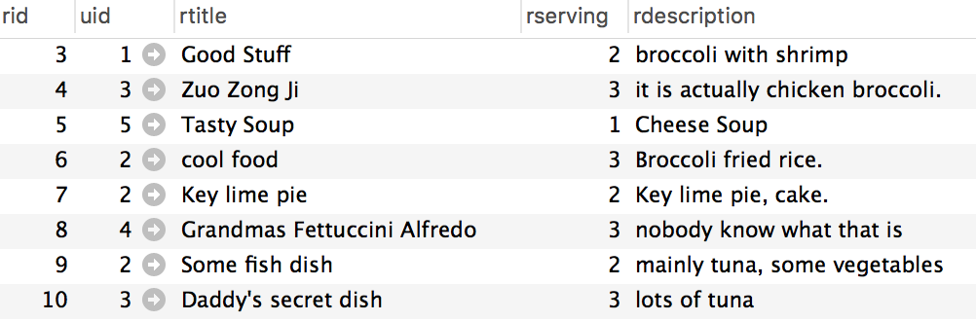

**Report Reserve**

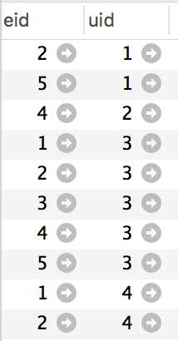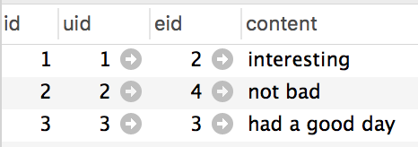

**Review**

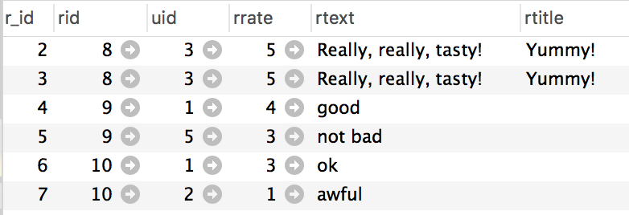

**Review_Suggestion Tag**

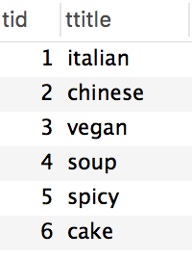 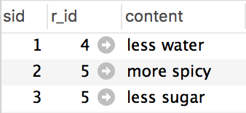

**Unit_Conversion**

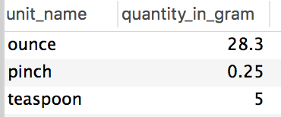

**User**

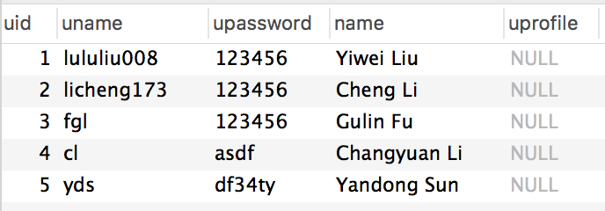

1. SQL Queries
2. Create a record for a new user account, with a name, a login name, and a password.

**Insert into** User (uname, upassword, name) **values** ('lululiu008', 123456, 'Yiwei Liu');

1. List all recipes with tag “italian” that contain the keyword ``broccoli’’.

**Select** *

**from** Recipe R **natural** **join** Recipe_Tag RT **natural** **join** Tag T

**where** T.ttitle = 'italian' **and** R.rdescription **like** '%broccoli%';

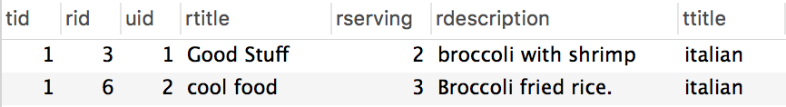

1. List all members of the group “Park Slope Cake Club” that have given a positive RSVP to more that three events of the group.

**Select** name

**From** user **natural** **join** reserve **natural** **join** event

**group** **by** uid, gid

**having** gid = (**select** gid **from** ggroup

**where** gname = 'Park Slope Cake Club') **and** **count**(event.eid) > 3

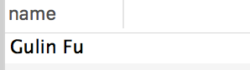

List all recipes with tag “cake” that contain more than 50 grams of sugar per serving.

1. INSERT INTO User VALUES ('licheng173', 'cheng li', 'Nyu1234!');

2. select *

from Recipe natural join Recipe_Tag

where tag = 'italian' and rdescription like '%broccoli'

3. SELECT

T.username

FROM

(

SELECT

r.username,

r.eid

FROM

Reserve r,

Hold_Event h,

GGroup g

WHERE

r.eid = h.eid AND g.gid = h.gid AND g.gname = 'Park Slope Cake Club'

) AS T,

Join_Group j,

GGroup g2

WHERE

T.username = j.username AND g2.gid = j.gid AND g2.gname = 'Park Slope Cake Club'

GROUP BY

T.username

HAVING COUNT

(T.eid) > 3;

4.

select r.rtitle, r.rid

from Recipe r natural join Recipe_Tag t natural join Ingredient i

where t.tag = 'cake' and i.iname = 'sugar' and i.iquantity/ r.rserving > 50;

5.

Insert Into Review values (1,null,null,5, 'Really, really, tasty', 'Yummy!');

6.

7.